Testing status
This document provides an overview of all on-chip memory test files that were executed as part of the validation process. The file structure shown below is taken directly from the project’s Git repository and includes all available test sets, including large-scale tests, multi-set groups, and individually generated unique tests. The tables below summarizes the execution status of each test file (according to the files names in the screenshot above) , indicating whether all tests passed successfully or if any failures occurred.
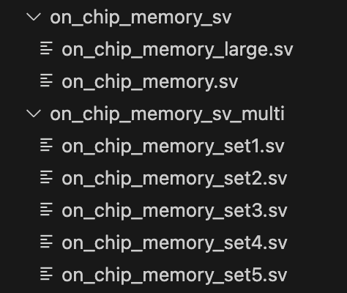

#failed tests | #passed tests | File name
0 | 500 | on_chip_memory.sv
0 | 500 | on_chip_memory_large.sv
0 | 500 | on_chip_memory_set1.sv
0 | 500 | on_chip_memory_set2.sv
0 | 500 | on_chip_memory_set3.sv
0 | 500 | on_chip_memory_set4.sv
0 | 500 | on_chip_memory_set5.sv
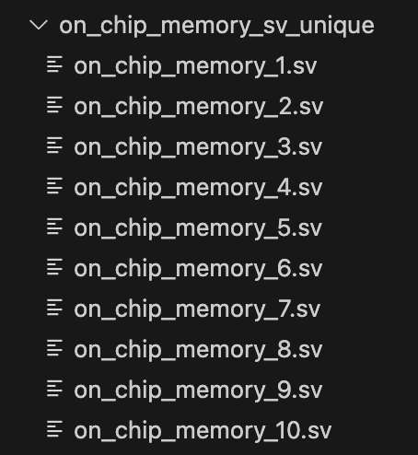

#failed tests | #passed tests | File name
0 | 500 | on_chip_memory_1.sv
0 | 500 | on_chip_memory_2.sv
0 | 500 | on_chip_memory_3.sv
0 | 500 | on_chip_memory_4.sv
0 | 500 | on_chip_memory_5.sv
0 | 500 | on_chip_memory_6.sv
0 | 500 | on_chip_memory_7.sv
0 | 500 | on_chip_memory_8.sv
0 | 500 | on_chip_memory_9.sv
0 | 500 | on_chip_memory_10.sv
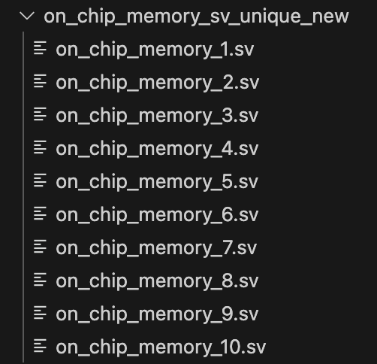

#failed tests | #passed tests | File name
0 | 490 | on_chip_memory_1.sv
0 | 490 | on_chip_memory_2.sv
0 | 490 | on_chip_memory_3.sv
0 | 490 | on_chip_memory_4.sv
0 | 490 | on_chip_memory_5.sv
0 | 490 | on_chip_memory_6.sv
0 | 490 | on_chip_memory_7.sv
0 | 490 | on_chip_memory_8.sv
0 | 490 | on_chip_memory_9.sv
0 | 490 | on_chip_memory_10.sv

Randomized Delay Stress Tests
The following table summarizes the results of stress tests executed with randomized signal delays. These tests aim to verify system robustness under non-ideal conditions, using the same set of input files that previously passed all 500 tests without issues.
Two types of randomized delays were tested:
- Data Stream Delay (Generator) - pauses during data transmission.
- Read Delay (Validator) - A randomized delay was inserted before capturing the DUT output, simulating timing variability during validation.
- Lowering chip_sel (Generator) - the chip_sel signal was intentionally dropped in the middle of a test. The system was expected to correctly restart the test from the beginning upon reassertion of chip_sel, ensuring no residual data from previous runs was retained.
These tests were run using the same generator and validator modules, modified to support internal delay injection, and are used to validate the system’s correctness under edge conditions.
#failed tests | #passed tests | Files executed on | delay type
0 | 500 | on_chip_memory_set1.sv | Data Stream Delay
0 | 500 | on_chip_memory_set2.sv
0 | 500 | on_chip_memory_set3.sv
0 | 500 | on_chip_memory_set4.sv
0 | 500 | on_chip_memory_set5.sv
0 | 490 | on_chip_memory_1.sv | Read result Delay
0 | 490 | on_chip_memory_6.sv
0 | 490 | on_chip_memory_2.sv | Lowering chip_sel during test
0 | 490 | on_chip_memory_8.sv

*Files are from on_chip_memory_sv_multi
*Files are from on_chip_memory_sv_unique_new

